AutoATC

Aviate
Navigate
Communicate

Version 0.9.8 February 2022

Aviation radio telecommunications simulator

AutoATC simulates Air Traffic Controllers (ATC) and traffic, capturing the experience of navigating complicated and busy airspace.

Using AutoATC will develop your Air Traffic Control communication skills, a vital component of aircraft safety.

The application includes everything required to practice and improve on all aspects of radio communication.

Ideal when used in Virtual Reality.

Join the discord server for open, free and friendly discussion with many other like minded flight and simulation enthusasts:
https://discord.com/invite/vBbESeu

Installation and User Guide

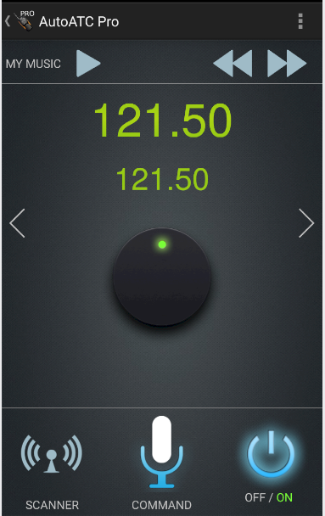

Table of Contents
Document changes: 2
Getting Started 3
ATC Communications 3
Ground School 3
Filing a flight plan 5
Your hanger 6
Routes, Departure and Arrival airports 9
Interactive Flight 11
Simulator Connection 11
Beginning a new flight 12
Using the Application 12
Making a transmission: 12
Vocabulary Training and Voice Commands 13
Frequency Scanner 13
Transponder Setting 14
Log window 14
Mini Map 15
FMC Integration 15
Call sign Registration 16
Installation: 18
AutoATC plugin for X-Plane (Free X Plane plugin) 18
Step 1: 18
Step 2 (Windows only): Install Microsoft updates: 18
Step 2 (MacOS only): Remove quarantine attribute: 18
AutoATC Radio for Xplane (free - Android application) 19
AutoATC Pro (Android application) 19
Setup 19
Control setup 20
Sound setup 20
Connecting to the android applications 21
Troubleshooting 22
Voice Recognition problems 22
My requests aren’t recognised 22
Cancelling/changing a transmission 22
Readbacks not recognised 22
747s Everywhere 22
Connection Problems & multi cockpit setups. 22
Windows 23
Reset Windows Firewall 24
Airframes 26
Version History 26
0.9.7 (December 2021): 26
0.9.6 (March 2021): 26
0.8.7 b1 (July 2019): 26
0.8.69 (May 2019): 26
0.8.6 rc2 (Febuary 2019): 27
0.8.6 Beta 2 (December 2018): 27
0.8.5.1 (November 2018): 27
0.8.4.2 (October 2018): 27
0.8.4 (October 2018): 27
0.7.3 (October 2018): 28
0.4.3 (September 2018): 28
0.4.2 (September 2018): 28
0.3.7 (August 2018): 28
0.2.0 (July 2018): 28

Document changes:
Version | Changes | Page
0.9.8 | Update settings description  Version History | 23  26
0.9.7 | Update installation instructions  Connection Problems & multi cockpit setups.  Airframes definitions  Version History | 18  23  26  26
0.9.6 | Rewrite document | N/A

Getting Started

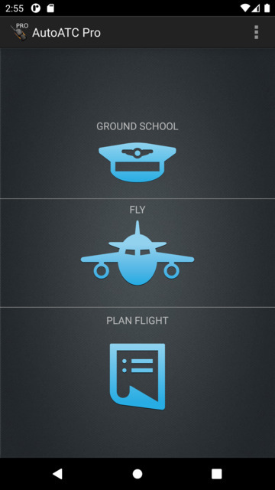
ATC Communications
Use AutoATC to learn radio procedures and follow them as if you are flying a real aircraft.

AutoATC uses speech recognition. This converts your transmissions into text which is then interpreted against standard radio procedure.

When starting the mobile applications for the very first time, you will be taken to the ground school section.

pressing/gesturing back, or pressing on the bar at the top of the page will bring you back to this page.

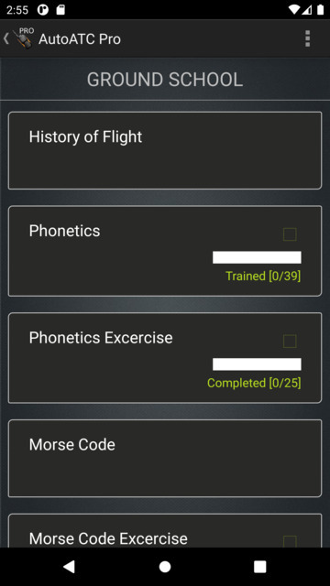
Ground School
Get started with radio communications procedure with the Ground School section. Theory and practice tests included with the application reinforce learning.

It also serves a secondary purpose to set the auto correction functions.

It is recommended at a minimum to complete the word training exercises before moving on to attempt communication with the AI air traffic controllers.

Word training increases recognition accuracy for procedural words which sound like other words and may be converted to text incorrectly.

Completing the word training sections therefore greatly reduces the need to repeat requests and required read backs by standardising the spelling of these words.

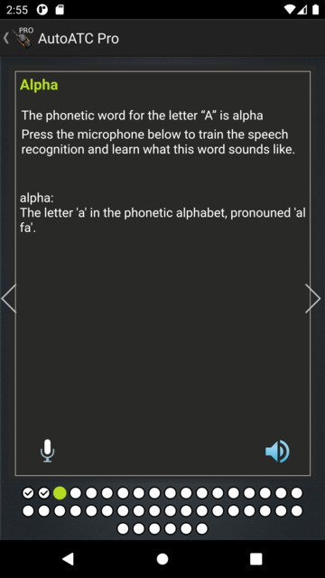
Each ground school section is divided into several pages of text and images, pages with associated word training will have a microphone in the lower left corner of the page.

Additionally, such pages will not “check” in the lower portion of the page if word training/auto correct has not been completed.

An example of this is the phonetic word “alpha”

Voice recognition works by creating a probability of a sound being a word.

The complete list of auto corrections can also be reached by selecting “auto correction” from the menu in the top right. Each sounds like must be unique, duplicates will be highlighted in red in the auto corrections list. New words can be manually added to this less by selecting the green plus at the bottom of the page.

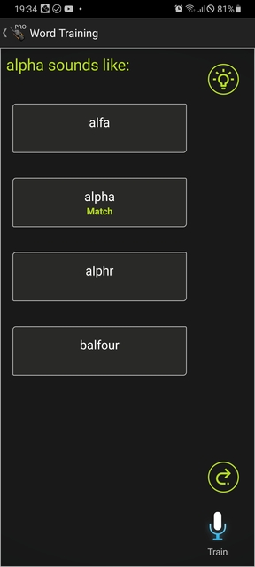
In the case of Alpha, the words alfa, alphr and balfour all “sound like” alpha.

By completing the word training, all of these alternatives will always be converted to “alpha”.

Repeat for any alternates you wish to be recognised (for example fife and five)
Swipe an item right to delete/clear.

Selecting the light bulb in the top right will give some brief information about how the word is used in radio procedure.

Press and hold train and then speak into the microphone to train the software which words sound like the word which should be used.

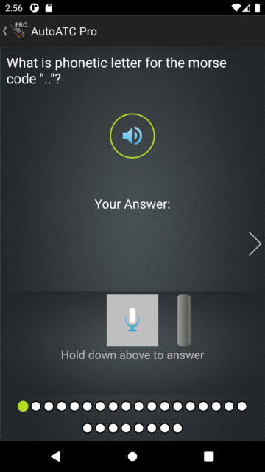
Practice tests chose up to 25 random questions for each section and are a mixture of multiple choice or voice recognised answers.

Once all questions have been answered (shown by a check mark in the lower page selector) the last page will mark the answers and display the correct answer to any incorrect answers. Additionally you can select incorrect answers to open the ground school page associated with it.

Filing a flight plan
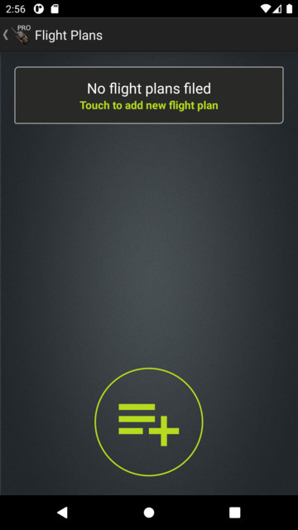
(Theory explained in more detail in the in application ground school)

VFR flights may (but are not required to) file a flight plan.
IFR flights must file a flight plan.

Regardless of where you are flying, both ICAO countries and the United States (FAA) have standardised on the ICAO flight plan form.

Selecting “Plan Flight” from the landing page opens the flight plan documentation section of the android application.

Once a flight plan is created it is listed on this page and must be filed in order to become active. The status of each flight plan will be given underneath it (when it was created, when it was filed, it it was rejected and the reason why).

New plans can be created by pressing the green plus. Existing plans can be filed, duplicated and edited (if not already successfully filed) by selecting the flight plan from the list.

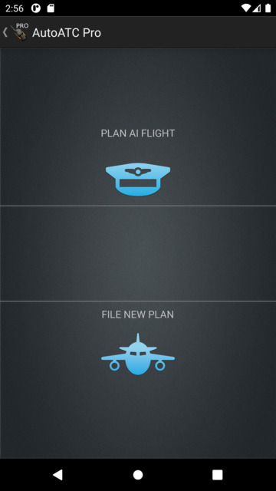
Two types of flight plan can be filed, an AI flight plan, or a user fight plan.

An AI flight plan will create an AI aircraft at the origin airport which will begin its flight at the departure time and fly to the destination airport.

When using the application in standalone mode the position of the user aircraft will follow this aircraft. When using AutoATC with a flight simulator this can be used to create “buddy” aircraft which can be followed through the flight and radio procedure.

Regardless of the option selected here, the information required is the same, and options and text boxes will presented once selected to fill in all the necessary information required to file the flight plan with the simulated Air Traffic Controllers.

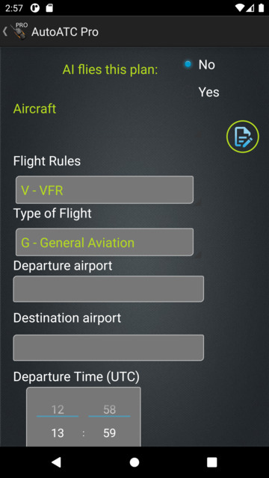
Your hanger
The android application stores details of the aircraft in your hanger for re use so they do not need to be entered each time, these can be selected by registration in the aircraft options. Initially the hanger will be empty and you will want to fill it with the aircraft you will be flying.

To add aircraft details select the edit icon to the right of the aircraft selection box. Entering aircraft details functions similarly to that of entering flight plan data

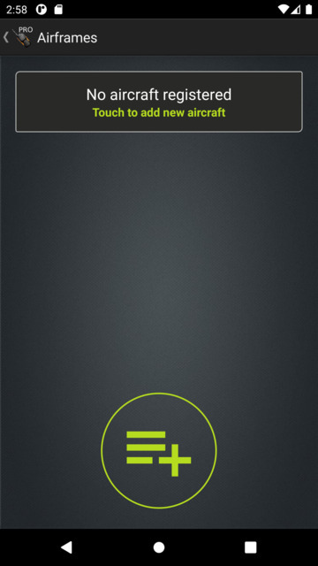
New aircraft can be added to your hanger by clicking on the plus sign at the bottom of the page.

Select an aircraft to view and edit its details (for example if a flight plan is rejected due to invalid data in the aircraft section of a flight plan.

Aircraft can be deleted by swiping their entry to the right.

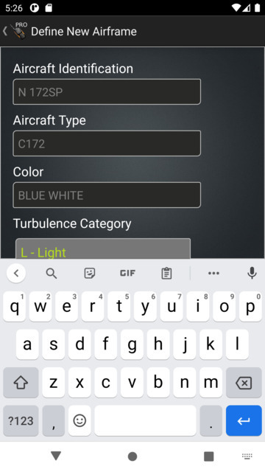
When defining a new airframe the aircraft identification is the ICAO call sign that will be used when registering your call sign.

This can either be a standard aircraft registration (e.g. C172 SP) or the ICAO code of the airline followed by an underscore and the flight number (BAW_1234 for “speedbird one two tree fower”).

Aircraft call signs are explained in more detail in the ground school materials and later in this document.

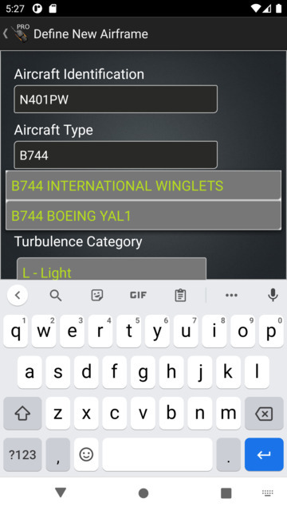

ICAO codes for all aircraft are included in the application, and the correct code for the aircraft you are using should be chosen so that Air Traffic Control can issue procedures broadly in line with your aircraft (such as giving helipads to helicopters and routing heavy aircraft around smaller).

This code is also used for the multiplayer aircraft.

The name of the aircraft type is also included and will be filtered while you type.

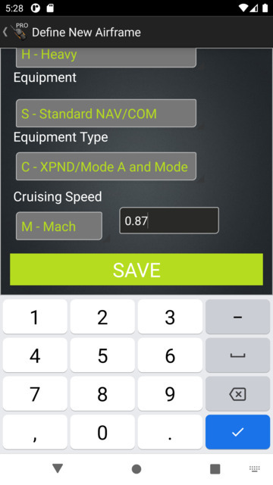

Once all the details for the airframe have been entered, scroll down to the bottom of the page, save them, and return to completing the flight plan.

Routes, Departure and Arrival airports
Departure and Destination airports are entered using their ICAO code. Airports without an ICAO code use the code “ZZZZ”.
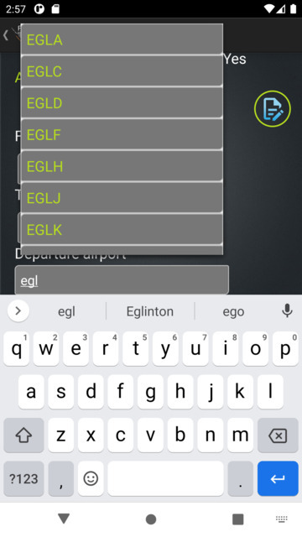
Xplane 11 .fms plans can also be imported into the appication, generated by sites such as flightplandatabase.com. Simply download the file on your Android device and open it with the application.

You will still need to plan the route in advance of filing, get retrieve weather reports and NOTAMs and select a reasonable time in the air given your expected cruise speed.

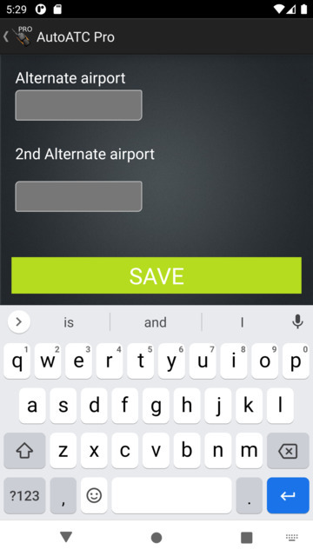

Once all the details have been completed, scroll down to the bottom of the page and save them, which will return you to the list of flight plans.

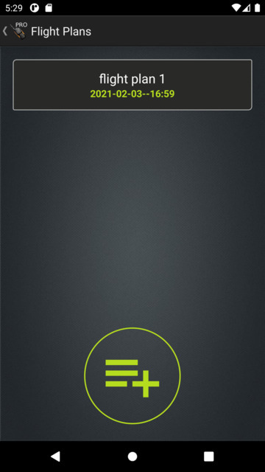
Saving a flight plan does not filed it for use. Once a flight plan is saved it will appear in the flight plans list for review. Swiping a plan right will delete it. Selecting it will open it as an ICAO Flight Plan form for review, with the option to duplicate it (when previously filed), edit or file it.

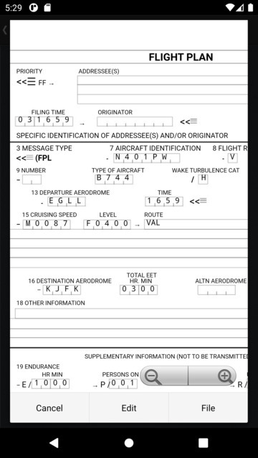
After reviewing the information in the flight plan it can be filed for use with the simulator.

The form displayed when reviewing a flight plan is the actual layout and format used in a ICAO flight plan form.

Once filed, AutoATC will update the entry in the flight plans list with the result (time filed, or reason for rejecting it)

Interactive Flight

The Application supports both simulator connection and self contained operation simulating the use of a VHF radio on the ground and in the air.

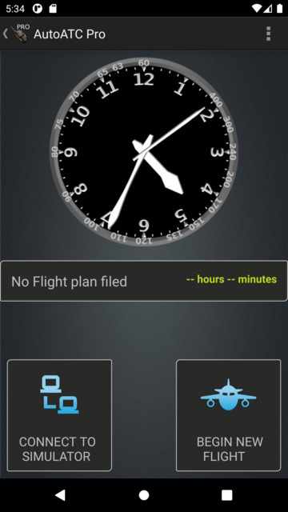
Selecting Fly from the landing page will open the begin flight page, from here you can select whether to connect to a simulator, or, if using the paid application begin a flight in self contained mode.

If you have filed a flight plan the remaining time before you are due to depart will be shown in the center of the page. All times in AutoATC are in UTC (Universal Coordinated Time – all aviation times are UTC; time explained in more detail in the Ground School).

From the page you can also configure your current location and other options by selecting settings from the menu in the top right of the page.

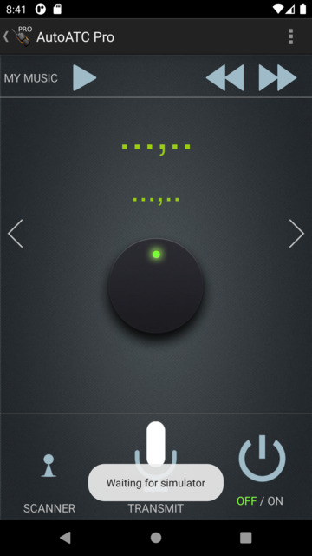
Simulator Connection
Selecting “Connect to Simulator” begins the application listening for the flight simulator to become active.

Connecting to a flight simulator allows both the simulator and the application to control Comm 1, to activate the voice transmission, what frequency is active and in standby.

The application takes its location information (used to determine what frequencies are in range) from the simulator.

This page will initially show “waiting for simulator” and will be otherwise inactive until a connection is established.

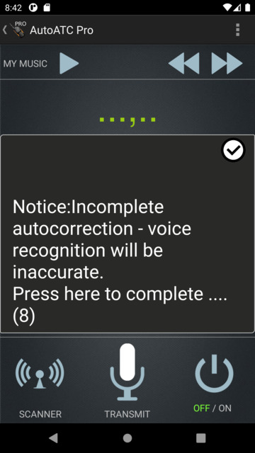
Beginning a new flight
Once the application is active (either by beginning a new flight or successfully connecting to a flight simulator), it will perform a quick check that all auto correct items are complete. If not, a notice will pop up for a short period suggesting they be completed.
Once the radio is powered on, the application will display the current and standby frequencies, standby the smaller lower frequency, active the larger upper frequency.
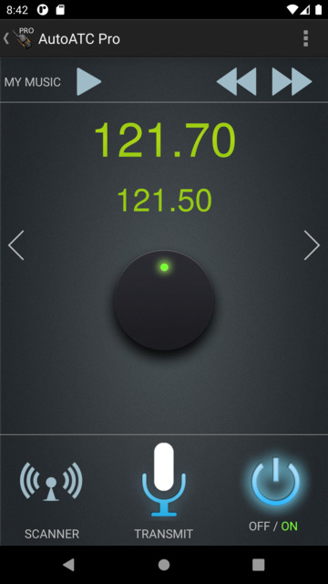
Nearby frequencies can be scrolled through by turning the dial, or selecting the scanner in the bottom left, active and standby can be swapped by pressing on either standby or active frequencies, or via the simulator controls for the radio.
To make a transmission, press and hold TRANSMIT and speak into the microphone.

Using the Application

Making a transmission:
To make a transmission, press and hold the transmit button and speak into the microphone. You voice will be converted to text and sent to the current controller.
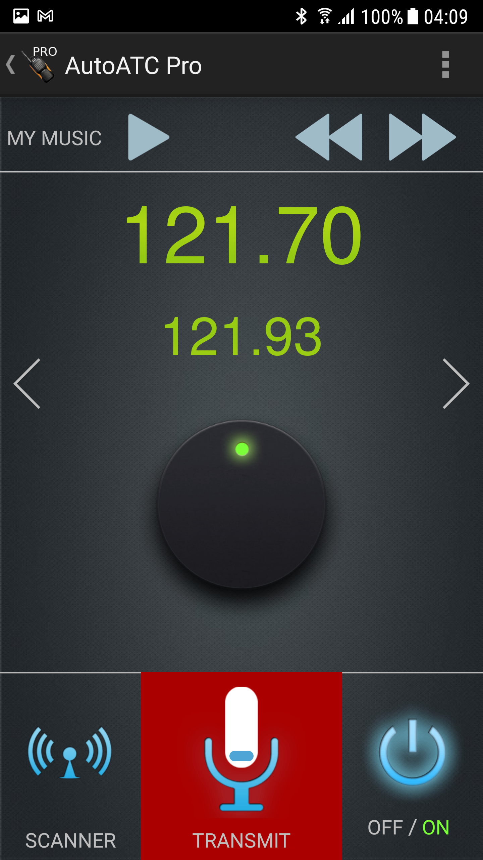
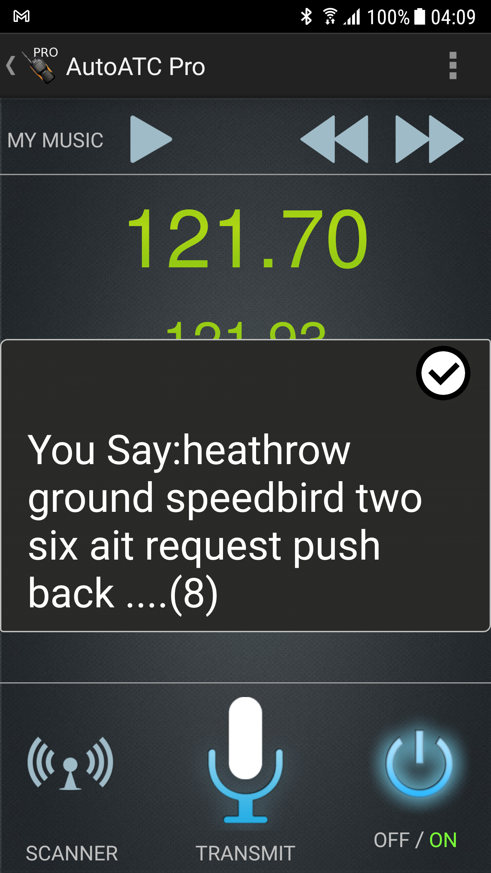
When you release the transmit button, your request will be converted to text and displayed for a short time, configurable in settings, before being sent. To correct the message before it is sent, press and transmit again before the timer expires.
Requests will not be received by a controller unless you have registered your call sign (see the next section), and are tuned to a radio receiver in range of your current position.

For best recognition accuracy and realism a headset with microphone should be used. Even those typically provided with mobile phones will greatly improve accuracy over a built in device microphone.

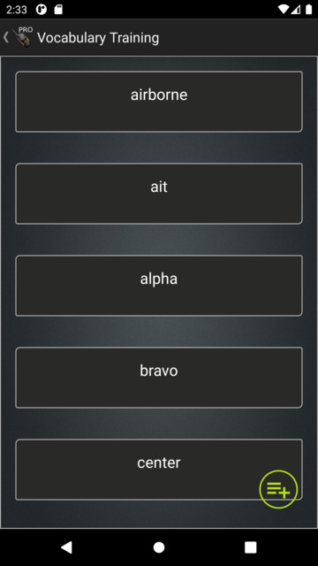
Vocabulary Training and Voice Commands
Some simulator aircraft may also include voice commands which will add to the vocabulary training list when they are first used (such as “gear up”)
The application should be trained what any empty auto correct options sound like for optimum performance.
The green plus in the bottom right can be used to add new auto corrections.

Frequency Scanner
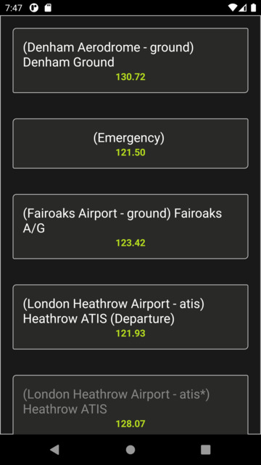
Reception of transmissions varies depending on location, altitude and surrounding terrain. AutoATC models these and periodically updates stations that should be able to receive radio communications from the current location.
This list of in range frequencies populates the next and previous radio frequency commands in the simulator, the dial on the frequency page, and also the scanner page within the application.
The scanner page shows the description of the frequency along with the frequency
Selecting an entry tunes the standby frequency.
Back exits.

The arrows to the left and right of the page scroll through the sub pages of the application, these can also be reached by swiping left and right on the page.

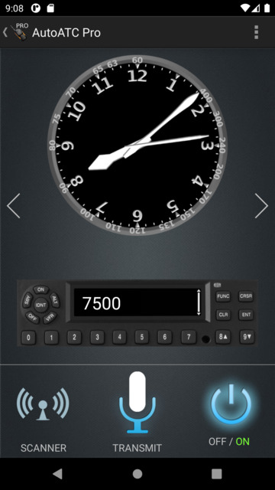
Transponder Setting
The transponder frequencies received from air traffic control can be set via the transponder page. This page also includes a clock displaying the current time in UTC.

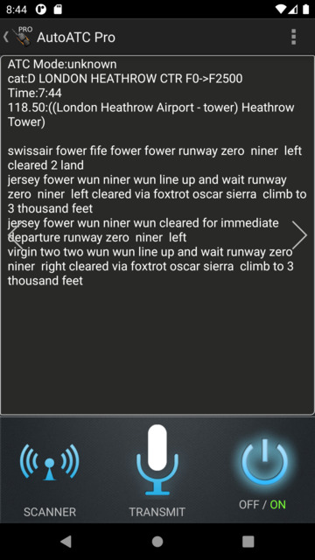
Log window
To aid in following the communications, the log window shows various information, such as the current airspace name and category, the station the radio is currently tuned to, along with a history of received and sent transmissions.

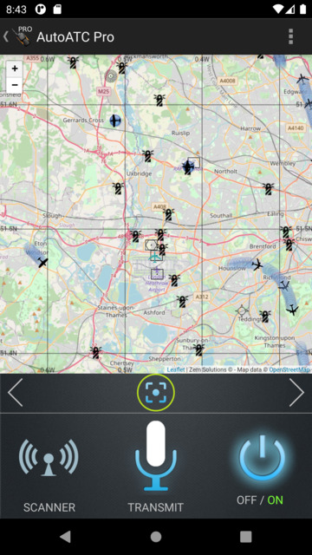
Mini Map
The mini map page centers on the local position, aircraft are shown with their current flightpath.
Most icons can be selected to view further information such as their name and Frequency:

NDB

VOR

DME

Waypoint Fix
VFR reference point

The circled point below the mini map can be used to return to the current aircraft position.
When the application is operating in self contained mode, the aircraft will move to the center of the map as the map is panned.

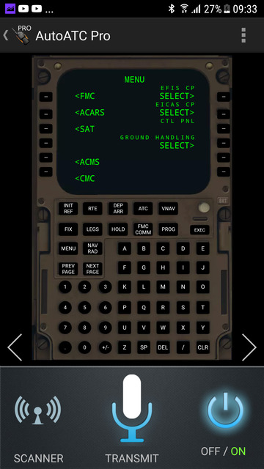
FMC Integration
When the application is connected to a compatible aircraft in the simulator (such as the Sparky747 overhaul), and extra page will become available to interact with the FMC remotely.

Call sign Registration

In order to communicate in AutoATC, you must first register your call sign.

A video walk-through of registering your call sign is available at:

https://www.youtube.com/watch?v=-3O4Wu1sbwA

To limit the potential disruption caused by bad voice recognition of call signs, and the burden of an unnecessary username and password system, two “special” ATC calls are used to register your call sign, which are then used when addressing you or replying to any further ATC calls.

These are “good day” and “radio check”.

Interaction with AutoATC is accomplished via the android phone applications, either the free AutoATC Radio when using X-Plane 11 or the paid version which can be used without the simulator.

As with real life radio, you should listen before transmitting to make sure you do not interrupt another transmission.

To maximise recognition accuracy, do not turn your head or vary the distance from the microphone being used with the phone application.

Use a normal conversational tone, but speak loud and clearly at a constant volume while enunciating each word, you must depress the transmit button before speaking and not release it to soon.

The correct rate of speech is about 100 words per minute.

While speaking, avoid hesitation and sounds such as “err” and “umm”, this is both bad radio practice and may cause the voice recognition to miss words.

There are three types of Aircraft call signs.
- Type A, used by general aviation, where the call sign is the full aircraft registration

- Type B, used by agencies, which is the agency designator plus the last 4 characters of the aircraft registration

- Type C, used for scheduled flights, which is the agency designator plus the flight number.

Call signs are are often abbreviated, in real life such abbreviations may only be initiated by air traffic control, and how they are abbreviated depends upon the call sign type.

Type A call signs – aircraft registrations, are shortened to the first character plus at least the last two characters, for example

“Belgrade Tower Golf Bravo Tango Romeo Yankee good day”

….

Alternatively the name of the aircraft manufacturer or model may be used in place of the first character, for example

“Belgrade Tower Piper Golf Bravo Tango Romeo Yankee request radio check”

….

Type B call signs – are similar to Type A call signs, except the operating agency designator is used instead of the aircraft manufacturer or model, for example

“Belgrade Tower Speedbird alpha bravo charlie delta radio check”

….

Type C call signs are not abbreviated, for example

“scandinavian 9 3 7 good day”

….

AutoATC has various other auto correct options, for example, military pilots often shorten “foxtrot” to “fox” (probably their favourite phonetic) AutoATC has the capability to autocorrect these and other common recognition errors as I become aware of them, for example

“Belgrade Tower Yankee Uniform Hotel Fox Kilo request radio check”
...
“Yankee Foxtrot Kilo Belgrade Tower readability 5”

After this, AutoATC will use this call sign even if you omit it or it is recognised incorrectly – this is a small limitation and while not enforced you should follow standard radio procedure when making your calls.

Installation:
AutoATC comes in three components:

AutoATC plugin for X-Plane (Free X Plane plugin)
- Listen to ATC communications
- Connect the simulator to the Android Applications
https://forums.x-plane.org/index.php?/files/file/45663-main-installation-files-for-autoatc-for-xplane-11/

Step 1:
If you have an existing installation, delete the folders:
X Plane 11/Resources/plugins/AutoATC
and
X Plane 11/Resources/plugins/AutoATC_java

Extract the AutoATC folder in the zip file to:
X Plane 11/Resources/plugins/

Which will result in the new folder:
X Plane 11/Resources/plugins/AutoATC

Step 2 (Windows only): Install Microsoft updates:

Two additional executables are included from Microsoft which add support for Multi threading and modern software support which do not ship by default with any windows version.

VC_redist.64.exe
and
vcredist_x64.exe

A critical vulnerability was recently found in the MFC component of vcredist2010 distributed with previous versions of the plugin.

All windows users should remove previous versions of Microsoft Visual C++ 2010 and run vcredist_x64.exe regardless of having previously installed it.

You can read more here:
https://www.microsoft.com/en-us/download/details.aspx?id=26999

Step 2 (MacOS only): Remove quarantine attribute:

New versions of MacOS add a quarantine attribute to any files downloaded from the internet which prevents them from running on the machine (this is a good thing). Unfortunately this adds an extra step to get them to run.

This requires manually removing the attribute, to do this, open a finder window and locate and select the X-Plane directory (default is your home directory).

Click on “Finder” followed by “Services,” and select “New Terminal at Folder.”

Then run the following command:

sudo xattr -dr com.apple.quarantine *

AutoATC Radio for Xplane (free - Android application)

- Talk to ATC in X Plane

https://play.google.com/store/apps/details?id=org.zem.atctrans

AutoATC Pro (Android application)
- Talk to ATC in X Plane,
- See the ATC controlled aircraft in X Plane
- Listen to ATC communications
- Practice talking to ATC anywhere.
https://play.google.com/store/apps/details?id=org.zem.atctranspro

Setup
Up to 30 of the closest AI planes will be added at any one time to the simulator

Each aircraft is controlled by the AI server and has it flight path modelled by the AutoATC pro android application.

The three styles currently supported are:

XSquawkBox style “CSL” models

https://forums.x-plane.org/index.php?/files/file/37041-bluebell-obj8-csl-packages/

These are specified in the file
airframes_bbcsl.json

“Bluebell XL” distributed by Jar Design:
http://jardesign.org/downloads/BBXL/BBXL-1.zip
http://jardesign.org/downloads/BBXL/BBXL-2.zip
http://jardesign.org/downloads/BBXL/BBXL-3.zip

These are specified in the file
airframes_bluebell.json

“World Traffic 3” models
https://forums.x-plane.org/index.php?/files/file/43952-wt3-airlines-and-aircraft-updates/

These require optimisation on first run, the AutoATC log window will display “Still building airframe index” while this is underway, and X-Plane will need restarting after it has completed to use all the airframes.
These are specified in the file
airframes_worldtraffic.json

In order to specify which airframe and livery X-Plane should use, airframe and livery are defined in the directory:

X Plane 11/Resources/plugins/java/airframe_definitions/

Each json file uses the expected default locations for these files, if you have installed them to a different location, you can find and replace in the json file to the directory they are installed.

Control setup
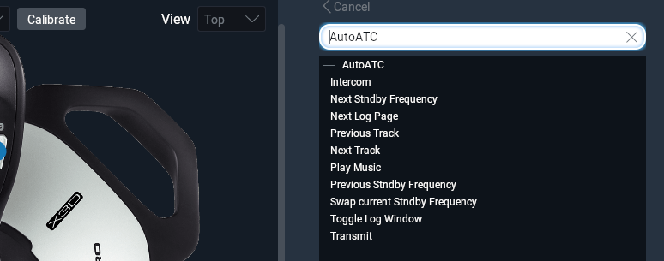
The plugin registers eleven Xplane commands.
- Intercom – use for voice commands
- Next Standby Frequency – move com1 standby frequency forward one.
- Next Log Page – Change the page displayed on the AutoATC Pad
- Previous Track – Play the previous music track on the android application.
- Next Track – Skip to the next music track on the android application
- Play music – play any mp3s on the android devices (requires accepting media permissions)
- Previous Standby Frequency – move com1 standby frequency back one.
- Swap current standby frequency – swap standby and current com1/adf/nav1 frequencies (depending on the current AutoATC pad page)
- Toggle Log window – show/hide the AutoATC pad
- Transmit – Begin voice recognition on a connected android application.

Sound setup
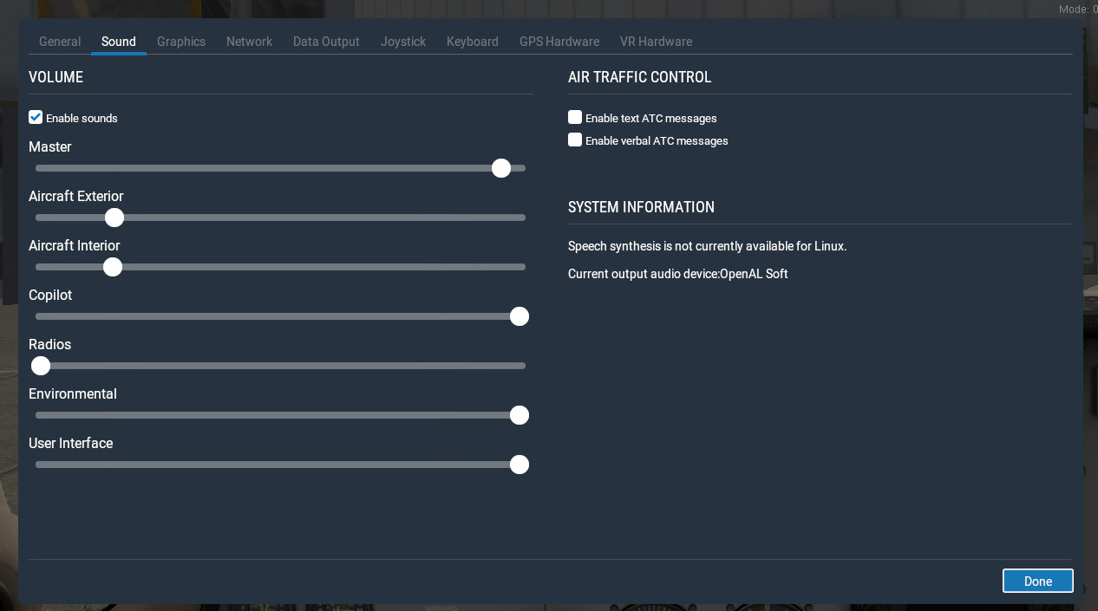
The volume of ATC voice in X-Plane is fixed at maximum volume, in order to stop the voice being drowned out by aircraft noises, turn down the volume of interior and exterior sounds in sound settings.
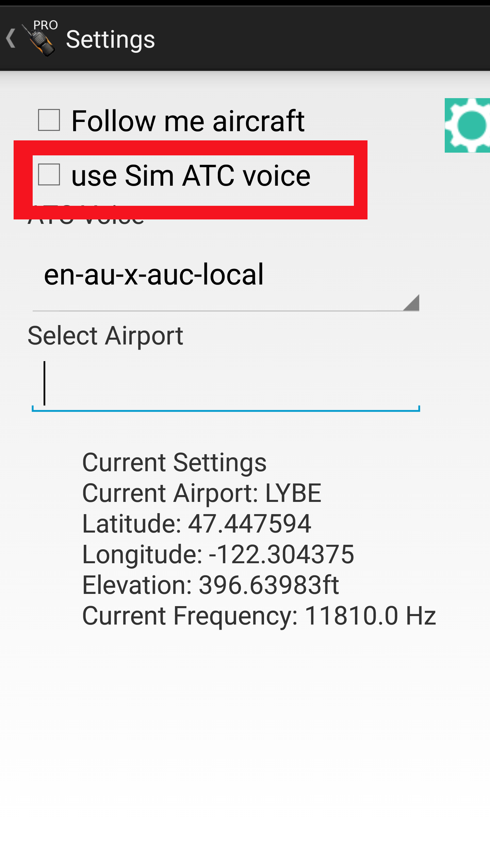

Alternatively, and preferred method, when using AutoATC Pro, disable “Use Sim ATC voice” in the application settings. You can then use a headset with the android device (wired or bluetooth) to both listen and talk to AutoATC.

Connecting to the android applications
Connection to the phone application should be entirely automatic and simply requires the device running the android application and the PC with X-Plane both to be on the same network.

If they are not on the same network, you may specify the device to use by specifying its IP address in

X Plane 11/Resources/plugins/java/mobilesettings.txt

If the Simulator only partially connects to the android device, you should check your PC firewall settings to ensure that the android application can connect to the PC, in windows this can usually be achieved by resetting the firewall to default.

Troubleshooting

Voice Recognition problems

My requests aren’t recognised
Currently, not all standard procedures are supported by AutoATC. As a general guide, if you hear an AI plane say something, you can say it to, either exactly or with some variation.

You can also refer to the ground school and phrase book for the format of the requests.

The only part of radio procedure which is strictly enforced is that to progress from one flight state to the next, you must correctly make the required read backs.

Additionally, when on the runway and ready to take off, the only command accepted by AutoATC is

“ready for departure”

At no point should you use the words “take off” unless reading back take off instructions.

If you hear the words

“report airborne”

This means you have been given permission to depart and take off at your own discretion. You should call tower with “airborne” once you are in the air.

Cancelling/changing a transmission
If you wish to retry voice recognition, press transmit again before the timer expires. The time between recognition completing and the message being acted upon can be changed in settings in the top right menu of the phone application under “transmit timer”.
Occasionally it has been noted that repeating the same sentence twice in a row results in recognition failing to complete. To work around this retry with a different message first (for example “testing”).

Readbacks not recognised
The most common cause for unexpected refusal to accept a read back response is back recognition of a required word, for example recognising “write” instead of “right” when reading back a runway name. Ensure all word training is complete.

747s Everywhere
AutoATC supports multiple model formats for AI aircraft, which give the aircraft their liveries and aircraft type. These are available from multiple sources that should be installed in addition to the simulator plugin.
When the plugin is first installed, the default aircraft for AI planes is likely to be a 747 and all AI aircraft will use this regardless of how they should appear. Review the setup section for links to install additional airframe support.
Liveries are matched to callsigns and airframe types are based on global real world flightplans.

Connection Problems, Audio device & multi cockpit setups.
There are two ways the X-Plane plugin can establish a connection to your Android device.
The default is what is called a “broadcast packet”, here the PC shouts on the network "I'm here and want a radio", the android application gets this message and replies with "connect to me here".
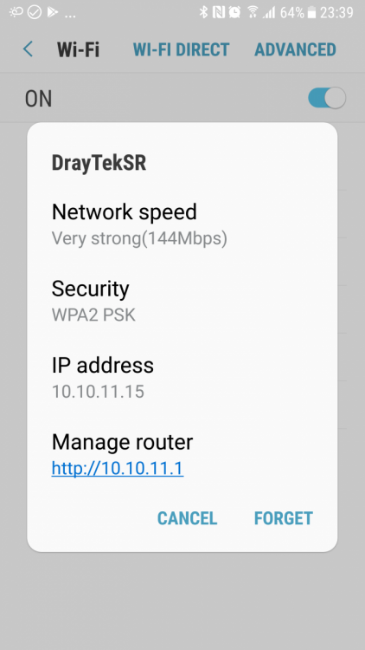
Some routers prevent these packets reaching the device.
The alternate when this happens is to specify the address of device.
To do this, get the IP address of the device from its network setting:
The IP address here is “10.10.11.15”

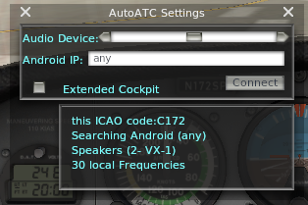
You can now enter this into the settings window (Plugins → AutoATC→Settings) in the plugin and press connect, after a few seconds it should now connect to the device.

Moving the “audio device” slider will change the audio device used for radio playback, you can test the output by pressing “connect”, which will play “radio check” on the currently selected audio device.

The “Extended Cockpit” checkbox on this window is used for slave machines of multi machine setups, selecting it will synchronize the AI aircraft display with the current machine and allow more than one machine to connect to the android device.

Windows
The windows JVM has a dependency on
﻿C:\windows\system32\msvcr100.﻿dll
Sometimes windows (particularly new machines, or ones without MS office) do not have this installed, ensure you have run both executable files included with the windows version of the plugin.

Reset Windows Firewall

If the mobile application and simulator are both on the same network and connection problems persist, Windows firewall may be preventing the plugin and the phone application from talking to each other, in order to reset the permissions and allow them to talk to each other, open windows settings, search for firewall and select “firewall & network protection.

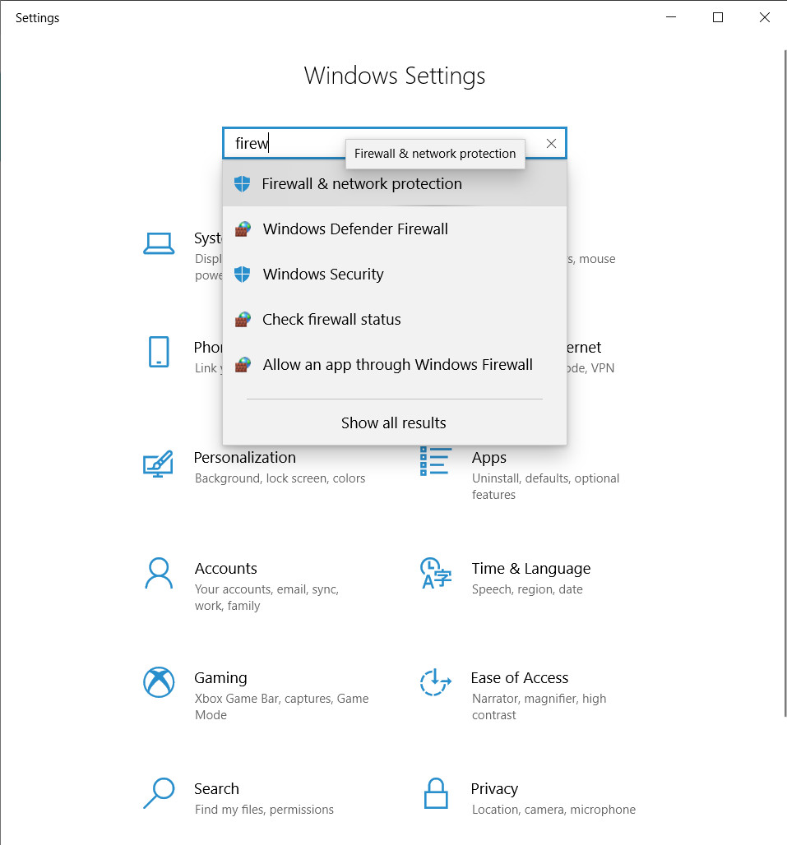

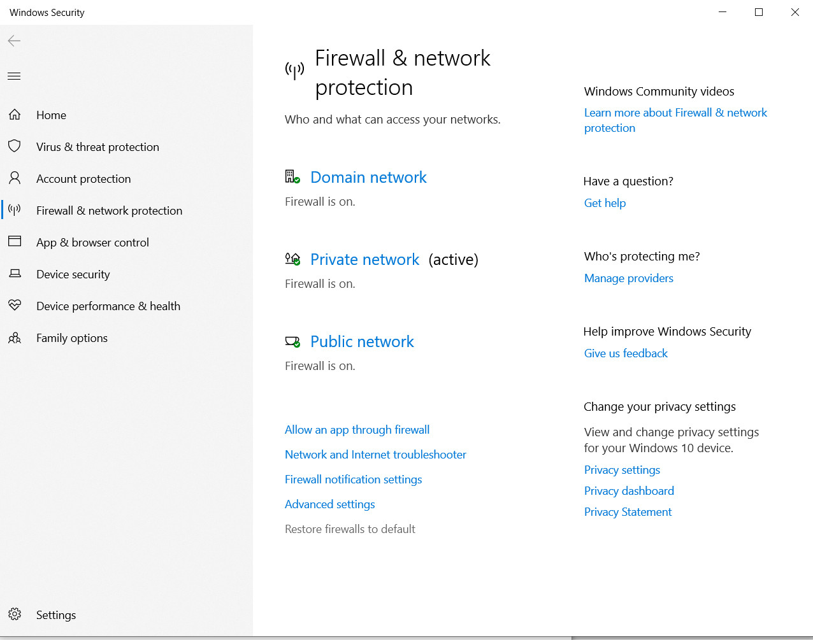
In the firewall & network protection window select “restore firewalls to default”

Press “Restore defaults”
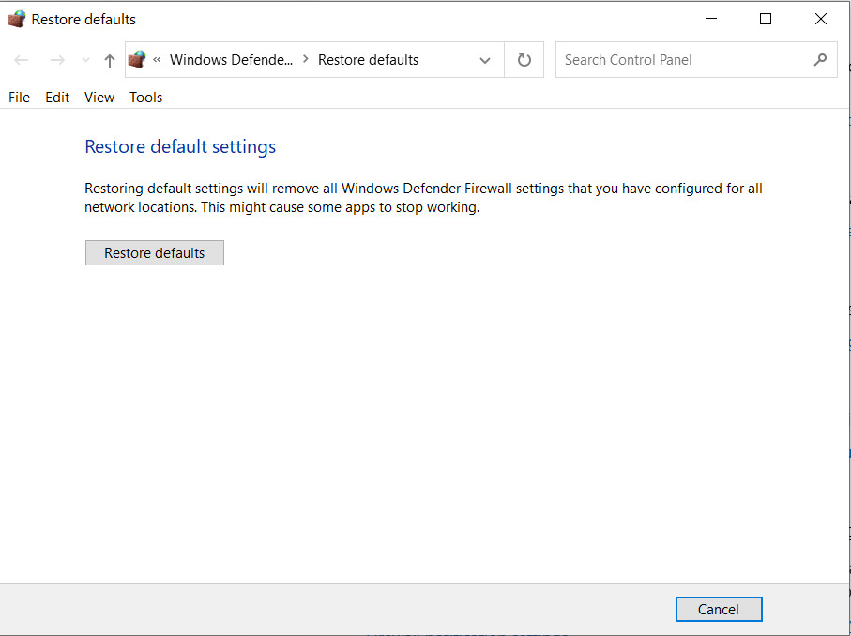

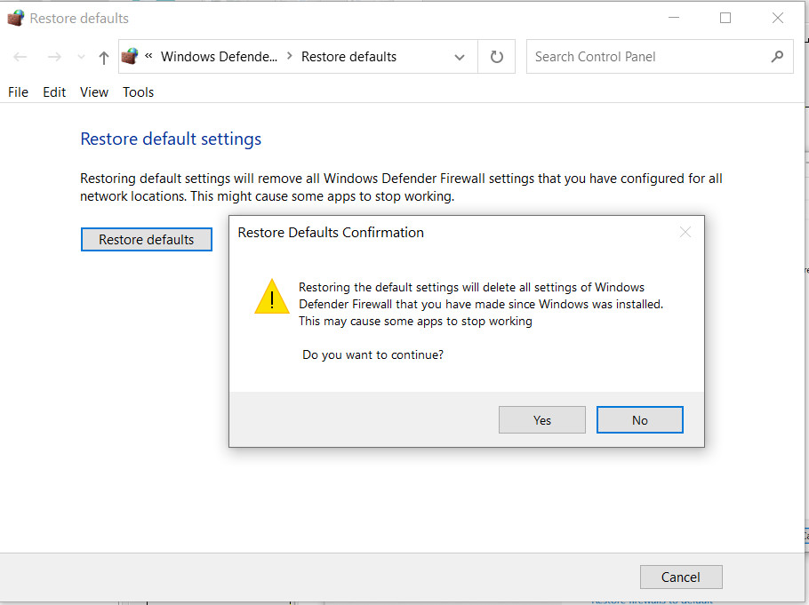
Press Yes to continue.

After the firewall has been reset, a dialogue will appear whenever a program is opened for the first time that uses the network, press “allow”.

Airframes
The airframes definitions directory contains several files in json format, which determine the object file which can be used for a particular airframe.

Key | Description
dref | The dataref style to use for animations
path | The path find the actual model
offset | Height to offset the model so that its wheels are on the ground
af | The airframe index, styled as “airframe” “operator”, e.g. A320_ASL is an Air Serbia call sign Airbus A320
icon | The icon to use on the X-Plane map
type | Currently “prop”,“jet”,”heli”, this is used to select the sound file to use.

Version 0.8.6 Beta 2 supports three styles of third party airframes. At each start, plugin will scan the directory installed files, and then create the file

X Plane 11/Resources/plugins/AutoATC_java/airframes_940.txt

This file should not be modified by hand, but can be inspected with wordpad to see which airframes were found.

Version History

0.9.8 (February 2022):
Support for changing output audio device.

0.9.7 (December 2021):
Follow me car (pro version android application support only)
Support clearing yousay popup from lua
Migrate to Java 17 for better performance and memory management, especially on lower end systems
ACARS/CPDLC fixes (Sparky744)
Apple M1 support

0.9.6 (March 2021):
Turbo prop sound type support and other audio improvements
You say popup
Fix nav tuning
Better libxplanemp object support
Add TCAS map layer
Fix drawing of high speed AI Aircraft
Pad background update
MacOS support and testing
ACARS support
Bundled openJ9 JVM

0.8.7 b1 (July 2019):
Better android integration (power control, frequency list, flight model etc)
Support for multi PC cockpits with AutoATC Pro android app (set external views as such in Plugins->AutoATC->Settings)
Fix for multiple Java plugins (see https://forums.x-plane.org/index.php?/forums/topic/175706-sharing-the-jvm/)

0.8.69 (May 2019):
RC1
Turn logging back on (ATCLog.txt)
miscellaneous fixes
Compatibility with android application version 0.8.69
B3
“always on” android connection to simulator and api version check.
Ground school
Separated simulator connection and standalone flight modes.
Innumerable bug fixes
LGPL plugin release at https://github.com/mSparks43/XPlane-11-AutoATC-plugin/
Support for custom voice command scripts.
Fixed Mac build.

0.8.6 rc2 (Febuary 2019):
Add vocabulary trainer to android application.
Increase log message visibility to 60 seconds
Add AutoATC/Toggle Log Window command

0.8.6 Beta 2 (December 2018):
Airframe definitions for 3rd party AI aircraft models + liveries
Automatically build airframe index from airframe definitions and installed models.
3D Surround Sound engine for AI planes
Added option to AutoATC Pro to always use android application for Text to Speech
- (allows use of a headset plugged into the android device to both hear and talk to ATC)
Added option to AutoATC Pro to select controller voice (with test readout)
Performance optimisations
Added simulator connection notifications to AutoATC for Xplane and AutoATC Pro android applications
Added ATC Logging to simulator plugin (ATCLog.txt)
AI aircraft now obey holding height instructions
AI aircraft now fly entire route when in the presence of a user

0.8.5.1 (November 2018):
Update default jvm to v1.8.192
Available frequency scanner
Next and previous frequency commands
Added "About" and version strings
Add recommended volume settings (seems to be the only way to get the volume right) and control setup screenshot
Track squawk and com1 frequencies on android display
depreciated voice.wav
Fixed occasional clipping/incomplete text to voice
multiple fixes for non functional airports

0.8.4.2 (October 2018):

Stop crash on "restart radio" (new .xpl files now included)
Recover from network software aborts
Add 2 new voices

0.8.4 (October 2018):

Improved voice recognition for longer sentances,
VR Support
Support for android app versions 0.8.4 onward:
New AI Server networking protocol - no more skipped messages.
Busy Skies v2: In simulator AI planes controlled according to ATC instructions (AutoATC Pro only)
voice recognition now displays in the ATC log for a few seconds before sending
- hit transmit before the timer ends to retry
RMS bar in the ATC log "(T)..." and phone apps to ensure voice is being heard by the phone apps
Refactored all the code to allow better testing and proceedure development.

0.7.3 (October 2018):

Merged common codebase for AutoATC Radio and AutoATC Pro

0.4.3 (September 2018):

Fix for some non working windows installations

0.4.2 (September 2018):

Second batch of ATC communication handling fixes.

Support for automatic synchronisation with phone apps (no need to set plane squawk before talking) - new phone applications required ("AutoATC for Xplane" > v1.2.2 or "AutoATC Pro" > v0.4.2), At time of writing may not be fully available from the play store.

Fixed "freeze on startup" (however, it can still take a few seconds to get going, check the AutoATC log from the menu for a change from "Radio powering up" to "ATC Mode:unknown" after powering up an aircraft to see when it is actually active)

0.3.7 (August 2018):

Mac OS support.

Better installation instructions included in the file,

Stability improvements to the plugin for installation setup.

Performance improvements, and better handling of networking failures.

"Busy Skies": All international airports (and a fair few others) now serviced by AI traffic.

First batch of ATC communication handling fixes.

0.2.0 (July 2018):

Added "restart radio" option to the menu.

Bound receiving and transmitting functionality to aircraft battery power (doesn't start until the battery is turned on, and stops when the battery is turned off)

added link to phone app and some more documentation in the description.

